THE RESCUE CARD
Project Report Submitted
In Partial Fulfillment of the Requirements
For the Degree of

BACHELOR OF ENGINEERING
IN
INFORMATION TECHNOLOGY

Submitted By
SHAHEERA KUBRA (1604-20-737-005)


INFORMATION TECHNOLOGY DEPARTMENT
MUFFAKHAM JAH COLLEGE OF ENGINEERING & TECHNOLOGY
(Affiliated to Osmania University)
Mount Pleasant, 8-2-249, Road No. 3, Banjara Hills, Hyderabad – 500034
2023-2024


MUFFAKHAM JAH

COLLEGE OF ENGINEERING & TECHNOLOGY

(
Est. by Sultan
-
Ul
-
Uloom Education Society in 1980)

(
Affiliated to Osmania Univer
sity, Hyderabad)

Approved by the AICTE & Accredited by NBA

CERTIFICATE

It is certified that the work contained in the project report titled “The Rescue Card” by Ms. Shaheera Kubra (1604-20-737-005) has been carried out under my/our supervision and that work has not been submitted elsewhere for a degree.

Project Supervisor Signature of Head
Dr. RAFI U ZAMAN Head ITD
Information Technology Dept. Information Technology Dept.
MJ College of Engineering & Tech. MJ College of Engineering & Tech.
Hyderabad – 500034. Hyderabad – 500034

External Examiner

8-2-249, Mount Pleasant, Road No.3, Banjara Hills, Hyderabad – 500 034
Phone: 040-23350523, 23352084, Fax: 040-2335 3428, Website: www.mjcollege.ac.in
DECLARATION

I, Shaheera Kubra , bearing Roll No. 1604-20-737-005, here by declare that the project report entitled “THE RESCUE CARD” is done under the guidance of Mr.Rafi U Zaman Associate Professor, Department of Information Technology, Muffakham Jah College of Engineering and Technology, is submitted in partial fulfilment of the requirements for the award of the degree of Bachelor of Engineering in Information Technology. This is a record of Bonafide work carried out by me in Muffakham Jah College of Engineering and Technology and the results embodied in this project have not been reproduced or copied from any source. The results embodied in this project report have not been submitted to any other University or Institute for the award of any degree.

SHAHEERA KUBRA (1604-20-737-005)

ACKNOWLEDGEMENT

The austerity and satisfaction that one gets on completing a project cannot be fulfilled without mentioning the people who made it possible with gratitude.
I am grateful to the almighty God who helped me all the way throughout the project and also has molded me into what I am today. I express my sincere thanks to my parents who always encouraged me to achieve my goals.
I offer my sincere thanks to MUFFAKHAM JAH COLLEGE OF
ENGINEERING AND TECHNOLOGY for granting me the opportunity to undertake my project in this esteemed institution.
I am Thankful to my guide Dr. RAFI U ZAMAN (Associate Professor, Information Technology Department) for his sustained inspiring Guidance and cooperation throughout the process of this project report.
I express my deep sense of gratitude and thanks to all the Teaching and NonTeaching Staff of my college who stood by me and aided me to make it a successful venture.

SHAHEERA KUBRA (1604-20-737-005)

The Rescue Card
ABSTRACT
Rescue Card is a multi-disciplinary project that encompasses several fields of engineering. It involves IOT as it is the interconnection of devices over the internet to enable sending SOS alerts, sharing location data, and more. Rescue Card is an Embedded System as it is a dedicated system with dedicated functions. There is an aspect of Communication technology that involves sending alerts and location data to register mobile numbers and leveraging Wi-Fi technology. A feature of our project involves information access using RFID/NFC technology. Storing and accessing data on the cloud involves the use of Cloud computing technologies. The Rescue Card can help parents monitor their children’s location, set up in-house safe zones, access their medical history in case of emergencies, and receive SOS alerts. Proposal of a system that an individual can wear as an ID card which has all the necessary hardware systems built in for SOS calls/messages and GPS. Different Solutions have an approach that includes a Mobile Application enabling access to send SOS alerts. The proposed system has the complete system built into the ID card. This approach enables a seamless experience for users across all age demographics as there is no setup process. Existing solutions such as mobile applications require users to understand smartphones which is not ideal for elderly users. Rescue Card is a compact and lightweight device that can be worn comfortably on the wrist or attached to clothing. It integrates various sensors and communication technologies to detect and respond to emergencies effectively. The Rescue Card IoT (Internet of Things) device is designed to bridge this gap by providing an immediate, reliable, and efficient means of alerting authorities and loved ones during critical situations. Equipped with GPS, accelerometers, and various sensors, the Rescue Card can detect critical situations such as falls, sudden impacts, or prolonged inactivity, automatically sending alerts to predefined contacts or emergency responders. Its user-friendly interface ensures accessibility for individuals of all ages, making it an essential tool for vulnerable populations such as the elderly, children, and those with medical conditions. By integrating advanced connectivity features and ensuring robust data security, the Rescue Card IoT Device aims to provide peace of mind and prompt assistance, ultimately saving lives and enhancing overall safety in everyday environments.

TABLE OF CONTENTS

INTRODUCTION...................................................................................................... 01
1.1 OBJECTIVE..................................................................................................................... 01
1.2 AIM OF PROJECT .........................................................................................................03
1.2.1 Providing safety using GPS location tracking.................................................... 03
1.2.2 Fall Detection through MEMS sensor……….....................................................04
1.2.3 Granting indoor access using RFID technology..................................................06

1.3 SIGNIFICANCE OF WORK…......................................................................................04

LITERATURE REVIEW.......................................................................................... 05
2.1 ARDUINO PROGRAMMING.…......................................................................05
2.2 FALL DETECTION............................................................................................06

SYSTEM ANALYSIS......................................................................................15
3.1 PROBLEM WITH EXISTING SYSTEM.........................................................15
3.1.1 VITHU Application...............................................................................15
3.1.2 The Stun Gun........................................................................................ 15
3.1.3 Fight back…………..………………………........................................15
3.1.4 Fragmented communication & limited
interoperability………………………………………………………..……16
3.2 PROPOSED SYSTEM…....................................................................................17
3.3 SOFTWARE REQUIREMENTS…..................................................................19
3.3.1 Arduino IDE...................................................................................19
3.3.2 Jupyter Notebook…………………..…………..............................20
3.3.3 Communication protocols & geolocation services……………….21
3.4 HARDWARE…...................................................................................................21
3.4.1 Arduino UNO controller…....................................................................21
3.4.2 U-blox 6 GPS module….......................................................................22
3.4.3 SIM800C GSM Module………………..……......................................23
3.4.4GY-291 ADXL3453-Axis Accelerometer Module…............................23
3.4.5 Arduino Baseboard specifications…………………………...………..24
3.4.6 Regulated Power Supply.......................................................................25
3.4.7 16X2 LCD Display and A Switch…………………………………….26
3.4.8 RFID Card………………………………………………..……...……26
3.4.9 LED- red diffused 5mm and buzzer………………..……………..…..27
3.5 SOFTWARE REQUIREMENT SPECIFICATION………………..…..........26
3.6 COST…...............................................................................................................27

SYSTEM DESIGN….......................................................................................28
4.1 CIRCUIT DIAGRAM….....................................................................................28

IMPLEMENTATION…..................................................................................35
5.1 ENABLING SOS ALERTS AND CONTROL USING IOT......................................35
5.1.1 Circuit Connections……………………………………………........................36
5.1.2 Coding...............................................................................................................37
5.1.3 Configure communication protocols………………………….………...……..38
5.1.4 Implement Emergency Detection Algorithms………………….....…………..39
5.1.5 Integrate Location Tracking…………………………….……………..
5.1.6 Develop SOS Alert Mechanisms…………………….………………
5.1.7 Enable Data Access and Storage………..………………………….
5.2 ESTABLISH BATTERY CONNECTION………………..….………..………… .....41
5.3 FALL DETECTION USING MEMS SENSOR…..…………………………
5.4 TEST FUNCTIONALITY..............................................................................................41
5.5 VALIDATE PERFORMANCE.....................................................................................43
RESULTS AND DISCUSSIONS……............................................................62
6.1 CLOUD DATA FOR ANALYSIS……………………..................................................62
6.2 THE RESCUE CARD HARDWARE............................................................................64
6.2.1 Initiating LCD Display.......................................................................................64
6.2.2 Fetching latitudes and longitudes……...............................................................64
6.2.3 Identification Using Authentication Card…………………….…................................66
6.2.4 Detection and sending SMS on sudden movements………………………..….67
6.2.5 SOS alerts and location tracking via SMS sent to emergency contacts...............69
6.2.6 Blinking of red LED and loud buzzer by pressing emergency button…...........70

CONCLUSION AND FUTURE WORK…..................................................... 69
7.1 CONCLUSION…............................................................................................................69
7.2 FUTURE SCOPE…........................................................................................................70

REFERENCES….............................................................................................71

APPENDIX I 33
APPENDIX II 33

LIST OF FIGURES

Figure No. | Figure Name | Page No.
1 | Framework | 10
2 | Node classification results under different class imbalance ratios. | 30

1. INTRODUCTION

  - OBJECTIVE

The Rescue Card project represents a multifaceted endeavour aimed at revolutionizing the landscape of emergency response systems through the innovative integration of advanced technologies and user-centric design principles. At its core, this ambitious undertaking is driven by a fundamental objective: to empower individuals, particularly those belonging to vulnerable demographics such as children and the elderly, with a robust and reliable means of summoning assistance during times of crisis or distress. With a holistic approach encompassing hardware development, software engineering, and user experience design, the project seeks to transcend conventional paradigms, offering a comprehensive solution that not only facilitates rapid emergency communication but also provides invaluable insights and support to both users and responders alike.

Central to the vision of the Rescue Card project is the creation of a wearable device that seamlessly blends into everyday life while serving as a potent tool for emergency preparedness and response. Designed in the form of an identification card, this compact yet sophisticated device is equipped with a myriad of embedded sensors, communication modules, and location tracking capabilities, enabling users to initiate SOS alerts and transmit vital information to designated contacts or emergency services with unprecedented speed and efficiency. By leveraging the power of the Internet of Things (IoT), the Rescue Card establishes seamless connectivity with a network of interconnected devices and platforms, facilitating real-time communication and data exchange in emergency scenarios.

The integration of Radio-Frequency Identification (RFID) and Near Field Communication (NFC) technologies further enhances the utility and versatility of the Rescue Card, enabling users to access critical information such as medical history, allergies, and emergency contacts with a simple tap or scan. This seamless access to personalized data not only empowers users to provide responders with vital insights into their medical condition and history but also facilitates more informed decision-making and intervention during emergency situations. Moreover, by harnessing the power of cloud computing, the Rescue Card ensures secure storage and retrieval of user data, enabling seamless synchronization across multiple devices and platforms while safeguarding privacy and confidentiality.

  - AIM OF PROJECT

    - Providing safety using GPS location tracking

The Rescue Card project places a significant emphasis on leveraging GPS location tracking technology to enhance user safety and security in emergency situations. This aspect of the project is central to its overarching aim of empowering individuals, particularly vulnerable demographics such as children and the elderly, with a reliable and effective means of summoning assistance when faced with adversity.

At its core, the integration of GPS location tracking capabilities into the Rescue Card device serves as a critical component of its emergency response system. By accurately determining the user's geographical coordinates in real-time, the device enables swift and efficient dispatch of assistance to individuals in distress. Whether it be a medical emergency, a natural disaster, or a personal safety concern, the ability to transmit precise location information to designated contacts or emergency services can make a crucial difference in the outcome of the situation.

One of the key objectives of the project is to harness the precision and reliability of GPS technology to ensure that users can be quickly located and rescued, even in challenging or remote environments. By providing responders with accurate location data, the Rescue Card enhances their ability to execute timely and effective intervention strategies, potentially saving lives and minimizing the impact of emergencies.

Furthermore, the integration of GPS location tracking into the Rescue Card device serves to enhance user confidence and peace of mind. Knowing that they can easily and reliably transmit their location to trusted contacts or emergency services in the event of an emergency, users are empowered to venture into unfamiliar or potentially risky environments with greater assurance. This sense of security not only enhances individual autonomy and freedom but also fosters a greater sense of resilience and self-reliance within communities.

In addition to its immediate benefits in emergency situations, the GPS location tracking functionality of the Rescue Card device also holds broader implications for public safety and disaster response efforts. By providing authorities with real-time information on the location of individuals in distress, the device enables more efficient allocation of resources and coordination of rescue operations, thereby optimizing the overall response to emergencies and enhancing community resilience.

Overall, the integration of GPS location tracking technology into the Rescue Card project represents a pivotal step towards achieving its overarching goal of providing safety and security to users in times of need. Through the seamless integration of this advanced technology into a user-friendly and accessible device, the project aims to empower individuals with the confidence and capability to navigate the challenges of everyday life while ensuring that help is never far away in times of crisis.

    - Fall Detection through MEMS Sensor

An essential aim of the Rescue Card project is to incorporate fall detection capabilities through Microelectromechanical Systems (MEMS) sensors, enhancing user safety by automatically triggering emergency alerts in the event of a fall or sudden impact. This feature addresses a critical need, particularly for vulnerable populations such as the elderly or individuals with mobility issues, who may be at increased risk of falls and related injuries.

The integration of MEMS sensors into the Rescue Card device enables real-time monitoring of user movements and orientation, allowing for the detection of sudden changes indicative of a fall or loss of balance. By analysing data from these sensors, the device can distinguish between normal activities and potential emergencies, triggering an automatic alert when abnormal motion patterns associated with falls are detected.

The implementation of fall detection technology through MEMS sensors not only provides an added layer of protection for users but also streamlines the emergency response process. In the event of a fall, the Rescue Card can immediately notify designated contacts or emergency services, providing them with vital information such as the user's location and medical history to facilitate a rapid and effective response. This proactive approach to emergency communication can significantly reduce response times and improve outcomes for individuals in distress.

Moreover, the integration of fall detection capabilities into the Rescue Card device contributes to the project's broader goal of fostering independence and autonomy for users. By automatically initiating emergency alerts in the event of a fall, the device empowers individuals to maintain their mobility and freedom without compromising their safety. This functionality is especially valuable for elderly users who may wish to continue living independently or engaging in outdoor activities with confidence and peace of mind.

The integration of fall detection technology through MEMS sensors represents a pivotal aspect of the Rescue Card project, aligning with its overarching aim of enhancing user safety and security in emergency situations.

    - Granting indoor access using RFID technology

Integrating RFID technology into the Rescue Card facilitates seamless indoor access to designated safe zones or secure locations, enhancing user safety and security. With a simple tap or swipe of their card, users can swiftly gain entry, ensuring rapid access during emergencies without encountering barriers. This feature not only expedites the process of accessing predefined areas but also grants users greater autonomy and flexibility in navigating indoor environments. By enabling individuals to define and manage access permissions, the Rescue Card empowers users to move confidently within their surroundings, whether seeking shelter during an evacuation or accessing a secure facility. This integration enhances the versatility and effectiveness of the Rescue Card, aligning with its overarching objective of providing users with reliable emergency response capabilities. Ultimately, by streamlining indoor access and bolstering security measures, the Rescue Card aims to enhance user safety and peace of mind in emergency situations.

Furthermore, the integration of RFID technology into the Rescue Card not only enhances access control capabilities but also facilitates efficient management of user information and resources. By leveraging RFID-enabled data storage solutions, the Rescue Card can securely store essential user data such as medical history, emergency contacts, and personal preferences. This centralized repository of information ensures that responders have access to vital insights and resources, enabling them to deliver targeted assistance tailored to the user's specific needs. Additionally, the Rescue Card can be configured to integrate with existing infrastructure, such as hospital systems or emergency response networks, further enhancing its interoperability and effectiveness in emergency situations. By harnessing RFID technology to streamline data management and resource allocation, the Rescue Card project aims to optimize emergency response efforts and improve outcomes for individuals in need.

  - SIGNIFICANCE OF WORK

- Empowerment of Vulnerable Populations
- Optimized Resource Allocation ensures efficient and targeted emergency response efforts.
- Solving Real world problems of Indoor Access
- With features like GPS tracking and RFID-enabled access, the Rescue Card instils confidence in users, allowing them to venture into various environments with assurance of immediate assistance.

2. LITERATURE SURVEY

2.1 ARDUINO PROGRAMMING

Arduino programs are written in the Arduino Integrated Development Environment (IDE). Arduino IDE is a special software running on your system that allows you to write sketches (synonym for program in Arduino language) for different Arduino boards. The Arduino programming language is based on a very simple hardware programming language called processing, which is like the C language. After the sketch is written in the Arduino IDE, it should be uploaded on the Arduino board for execution.

Here, setup () is the preparation block and loop () are an execution block. The setup function is the first to execute when the program is executed, and this function is called only once. The setup function is used to initialize the pin modes and start serial communication. This function must be included even if there are no statements to execute.

void setup ()
{
pinMode (pin-number, OUTPUT); // set the ‘pin-number’ as output pinMode (pin-number, INPUT); // set the ‘pin-number’ as output
}
After the setup () function is executed, the execution block runs next. The execution block hosts statements like reading inputs, triggering outputs, checking conditions etc.

In the above example loop () function is a part of the execution block. As the name suggests, the loop () function executes the set of statements (enclosed in curly braces) repeatedly.

void loop ()
{
digitalWrite(pin-number, HIGH); // turns ON the component connected to ‘pin-number’ delay (1000); // wait for 1 sec
digitalWrite (pin-number, LOW); // turns OFF the component connected to ‘pin-number’ delay (1000) ;//wait for 1 sec
}
Note: Arduino always measures the time duration in millisecond. Therefore, whenever you mention the delay, keep it in milliseconds.

Function Declaration:

A function is declared outside any other functions, above or below the loop function. We can declare the function in two different ways:
The first way is just writing the part of the function called a function prototype above the loop function, which consists of −
- Function return type
- Function name
- Function argument type, no need to write the argument name Function prototype must be followed by a semicolon (;).

pinMode() Function

The pinMode() function is used to configure a specific pin to behave either as an input or an output. It is possible to enable the internal pull-up resistors with the mode INPUT_PULLUP. Additionally, the INPUT mode explicitly disables the internal pull-ups. pinMode() Function Syntax

Void setup ()
{
pinMode (pin, mode);
}
● pin − the number of the pin whose mode you wish to set
● mode − INPUT, OUTPUT, or INPUT_PULLUP.

digitalWrite() Function

The digitalWrite() function is used to write a HIGH or a LOW value to a digital pin. If the pin has been configured as an OUTPUT with pinMode(), its voltage will be set to the corresponding value: 5V (or 3.3V on 3.3V boards) for HIGH, 0V (ground) for LOW. If the pin is configured as an INPUT, digitalWrite() will enable (HIGH) or disable (LOW) the internal pullup on the input pin. It is recommended to set the pinMode() to INPUT_PULLUP to enable the internal pull-up resistor.
If you do not set the pinMode() to OUTPUT, and connect an LED to a pin, when calling digitalWrite(HIGH), the LED may appear dim. Without explicitly setting pinMode(), digitalWrite() will have enabled the internal pull-up resistor, which acts like a large current limiting resistor.

digitalWrite() Function Syntax

void loop ()
{
digitalWrite (pin, value);
}
- pin − the number of the pin whose mode you wish to set
- value − HIGH, or LOW

2.2 FALL DETECTION

In the realm of fall detection, numerous studies underscore the critical importance of this capability in enhancing the effectiveness of emergency response systems, particularly for vulnerable populations such as the elderly. Fall detection systems have garnered significant attention due to their potential to mitigate the adverse consequences of falls, which are a leading cause of injury and mortality among older adults.
Research in this area has explored various methodologies and technologies for fall detection, ranging from wearable sensors to ambient sensing systems. Wearable devices, equipped with inertial sensors such as accelerometers and gyroscopes, have emerged as a prominent approach for detecting falls in real-time. These sensors capture movement patterns and orientation changes, allowing algorithms to distinguish between normal activities and falls based on characteristic motion signatures. Studies have demonstrated the feasibility and effectiveness of wearable sensors in accurately detecting falls and triggering timely alerts to caregivers or emergency services.

Additionally, ambient sensing technologies, such as motion detectors and depth cameras, offer alternative approaches for fall detection in indoor environments. These systems leverage environmental cues and spatial information to detect falls and raise alarms when anomalous events occur. While less intrusive than wearable devices, ambient sensing systems may face challenges related to environmental variability and privacy concerns.

Furthermore, recent advancements in machine learning and artificial intelligence have shown promise in improving the accuracy and reliability of fall detection algorithms. By leveraging large datasets and advanced pattern recognition techniques, researchers have developed more robust models capable of distinguishing falls from activities of daily living with greater precision.

3.SYSTEM ANALYSIS

3.1 PROBLEM WITH EXISTING SYSTEM

3.1.1 Vithu Application

This is an emergency app initiated by a popular Indian crime television series “Gum rah” aired on Channel [V]. Vithu is an emergency App that, at the click of the power button of your Smartphone 2 times consecutively, begins sending out alert messages every 2 minutes to your contacts that you feed into the app as the designated receivers or guardians. The message says "I am in danger. I need help. Please follow my location”. Overall, while the Vithu app aimed to provide a valuable service in enhancing personal safety, its shortcomings in performance, usability, privacy, and reliability have hindered its effectiveness as an emergency response tool.

3.1.2 The Stun Gun

This small gun charges an attacker with an electric shock. The shock weakens the attacker temporarily, giving you a sample chance to escape the scene. When its trigger is pulled, a stun gun pumps about 700,000 volts into the attacker’s body. Some stun guns are small enough to be concealed in a pack of cigarettes. They run on Lithium batteries can be carried either in handbags or held in waist straps. Stun guns, while intended to provide a non-lethal means of self-defence, have faced criticism and scrutiny due to several inherent issues and concerns. One primary problem is their potential for misuse or abuse, as they can inflict significant pain and injury when used improperly or inappropriately. This misuse may occur in situations where individuals lack proper training or judgment, leading to unintended harm to both the user and the target.

Another significant concern with stun guns is their limited range and close proximity requirement for effective use. Unlike other self-defences tools such as pepper spray or tasers, stun guns typically require direct contact with the target's body to deliver a shock, which may pose challenges in scenarios where the attacker is at a distance or moving quickly.

Moreover, the legal and regulatory landscape surrounding stun guns varies widely across jurisdictions, with some areas imposing strict restrictions or outright bans on their possession and use. This patchwork of regulations can create confusion among users and law enforcement officials and may contribute to inconsistent enforcement and oversight.

3.1.3 Fight back Application

Fightback app is a very basic app like ones listed above. However, one unique feature we like about the app is the Facebook status update. Apart from providing SMS and Email options to alert the other person during distress, this app also updates your Facebook status.

One prominent issue is the app's inconsistent performance, with users reporting instances of failure to trigger alerts or deliver notifications during emergency situations. This unreliability undermines the app's core functionality and diminishes its utility as a reliable safety tool.

Furthermore, users have expressed concerns about the app's user interface and overall usability, noting that it can be confusing to navigate and configure, especially in high-stress situations. Complicated setup processes and unclear instructions have also been cited as barriers to adoption, limiting the app's accessibility to a broader audience.

3.1.4 Fragmented communication & limited interoperability

Fragmented communication and limited interoperability pose significant challenges to the effectiveness of existing emergency response systems, undermining their ability to coordinate and execute timely and coordinated responses to crises.

The fragmented nature of communication within emergency response systems often arises from disparate technologies, protocols, and organizational structures. Different agencies and organizations involved in emergency response may use proprietary communication systems or operate in silos, leading to disjointed communication channels and delays in sharing critical information. This fragmentation can impede the seamless flow of data between stakeholders, resulting in inefficiencies in decision-making and response coordination.

Moreover, limited interoperability exacerbates the problem by hindering the integration and exchange of information between different systems and platforms. Incompatible technologies and data formats make it challenging for emergency responders to access and share vital information across agencies and jurisdictions, hampering collaborative efforts to address emergencies effectively.

The consequences of fragmented communication and limited interoperability are far-reaching. During large-scale emergencies or disasters, such as natural disasters or terrorist attacks, the lack of coordination and interoperability can lead to confusion, duplication of efforts, and delays in aiding with those in need. Moreover, the inability to share real-time information across different response teams can result in missed opportunities for early intervention and resource optimization.

Addressing these challenges requires concerted efforts to enhance communication infrastructure, promote interoperability standards, and foster collaboration among emergency response stakeholders. By investing in interoperable technologies, data sharing protocols, and training programs, emergency response agencies can improve their ability to communicate effectively and coordinate response efforts seamlessly, ultimately enhancing their capacity to protect lives and mitigate the impact of disasters and emergencies.

3.2 PROPOSED SYSTEM

The approach to the problem is a RESCUE card which can be worn by all age groups like a regular ID card which can consist of the SOS features including:

- Call & SMS Alerts
- Location tracking
- Fall Detection
- Attendance Management
- LCD lights
- Buzzer

The proposed Rescue card introduces a comprehensive safety system seamlessly integrated into an ID card.This innovative solution not only incorporates SOS functionality, and medical history access but also eliminates the reliance on external mobile applications. By embedding all necessary hardware systems within the ID card, the proposed system ensures a user-friendly experience across all age demographics. This approach prioritizes accessibility and convenience, particularly benefiting elderly users who may find traditional smartphone setups challenging.

Tools used for the proposed approach Microcontroller GSM Module Wi-Fi Module BMS System. Dimensions of the device would roughly be around 164.00 x 77.00 x 10.00mm (height x width x thickness) that is comparable to an average sized smartphone. The ID card is powered by a rechargeable battery that can be charged. It saves lives by providing access to required information necessary for medical professionals.

It is cost effective and can be mass produced at a low price. It can be easily accessible and can be worn around the neck or clipped to the clothes. It can be integrated with the existing ID card system and can integrate with attendance management systems. System has a long battery life and can last for several days on a single charge.

The envisioned framework of the Rescue Card project entails a comprehensive integration of cutting-edge technologies and user-centric design principles to create an innovative emergency response system. At its core, the proposed system revolves around the development of a wearable device, designed in the form of an ID card, embedded with a suite of advanced sensors, communication modules, and location tracking capabilities.

The primary objective of the proposed system is to empower users, particularly vulnerable demographics such as children and the elderly, with a reliable and efficient means of summoning assistance in times of distress or emergency. By seamlessly integrating IoT connectivity, GPS location tracking, and fall detection technologies, the system aims to provide users with a comprehensive safety net, capable of detecting emergencies in real-time and initiating timely alerts to designated contacts or emergency services.

Furthermore, the proposed system incorporates RFID/NFC technology to facilitate seamless access to critical information such as medical history, allergies, and emergency contacts. This enables responders to make informed decisions and provide targeted assistance tailored to the user's specific needs, thereby enhancing the effectiveness of emergency response efforts.

The user interface of the proposed system is designed to be intuitive and user-friendly, catering to users of all age demographics and levels of technological proficiency. By minimizing setup processes and complexities, the system aims to ensure accessibility and ease of use, empowering users to take control of their safety and well-being with minimal effort or expertise required.

Overall, the proposed system of the Rescue Card project represents a holistic approach to emergency response, combining advanced technologies with a user-centric design philosophy to create a versatile and effective safety solution.

3.3 SOFTWARE REQUIREMENTS

3.3.1 Arduino IDE

The open-source Arduino Software (IDE) makes it easy to write code and upload it to the board. This software can be used with any Arduino board. The IDE also offers a wide range of libraries that simplify the process of programming and interfacing with various sensors, motors, and other peripherals.

3.3.2 Jupyter Notebook

Jupyter Notebook is an open-source web application that allows users to create and share documents containing live code, equations, visualizations, and narrative text. It is widely used in data science and machine learning projects as it provides an interactive environment for data analysis and experimentation. With Jupyter Notebook, users can write and run code in a variety of programming languages such as Python, R, and Julia. Jupyter Notebook also supports the integration of various data science libraries, making it a popular choice for prototyping and sharing code. Its ability to produce shareable and reproducible reports, make it an ideal tool for presenting findings and insights in a software requirement project. Overall, Jupyter Notebook is an essential tool for any project that requires data analysis, visualization, and experimentation.

3.3.3 Communication protocols & geolocation services

HTTP (Hypertext Transfer Protocol): HTTP is a widely used protocol for communication between web clients and servers. In the context of the Rescue Card project, HTTP can be employed for transmitting data between the mobile application, backend servers, and cloud-based services. It enables the exchange of SOS alerts, location updates, and other critical information in a standardized format
.
MQTT (Message Queuing Telemetry Transport): MQTT is a lightweight and efficient messaging protocol designed for constrained devices and unreliable networks. It is well-suited for IoT applications, making it ideal for communication between the Rescue Card device and backend servers. MQTT facilitates real-time data transmission, ensuring timely delivery of emergency alerts and status updates.

WebSocket: WebSocket provide a bidirectional communication channel between web clients and servers, enabling full-duplex, low-latency communication. In the context of the Rescue Card project, WebSocket can be utilized for establishing persistent connections between the mobile application and backend servers, facilitating instant transmission of emergency alerts and location updates.

Google Maps API: Google Maps API offers a comprehensive set of mapping and geolocation services that can be integrated into the Rescue Card mobile application. It provides functionalities such as displaying maps, geocoding (converting addresses into geographic coordinates), reverse geocoding (determining addresses based on coordinates), and real-time location tracking.

OpenStreetMap (OSM): OpenStreetMap is an open-source mapping platform that provides free access to map data and geolocation services. It offers similar functionalities to Google Maps API, including map rendering, geocoding, and routing. Integrating OpenStreetMap into the Rescue Card application offers flexibility and cost-effectiveness, particularly for projects with budget constraints or open-source preferences.
Geolocation APIs: In addition to map rendering, geolocation APIs can be used to retrieve the device's current location, track movement, and calculate distances. Platforms like HTML5 Geolocation API or native mobile geolocation APIs (e.g., Core Location for iOS, Google Location Services for Android) enable the Rescue Card application to access the device's GPS coordinates and provide accurate location-based services.

By leveraging these communication protocols and geolocation services, the Rescue Card project can establish robust communication channels and implement accurate location tracking functionalities, ensuring effective emergency response and user safety.

3.4 HARDWARE

3.4.1 Arduino UNO controller

The Arduino Uno is a microcontroller board based on the ATmega328 (datasheet). It has 14 digital input/output pins (of which 6 can be used as PWM outputs), 6 analog inputs, a 16 MHz ceramic resonator, a USB connection, a power jack, an ICSP header, and a reset button. It contains everything needed to support the microcontroller; simply connect it to a computer with a USB cable or power it with a AC-to-DC adapter or battery to get started.
The Uno differs from all preceding boards in that it does not use the FTDI USB-to-serial driver chip. Instead, it features the Atmega16U2 (Atmega8U2 up to version R2) programmed as a USB-to-serial converter.
Revision 2 of the Uno board has a resistor pulling the 8U2 HWB line to ground, making it easier to put into DFU mode.
Revision 3 of the board has the following new features:
⦁1.0 pinout: added SDA and SCL pins that are near to the AREF pin and two other new pins placed near to the RESET pin, the IOREF that allow the shields to adapt to the voltage provided from the board. In future, shields will be compatible both with the board that uses the AVR, which operates with 5V and with the Arduino Due that operates with 3.3V. The second one is a not connected pin that is reserved for future purposes.
⦁Stronger RESET circuit.
⦁Atmega 16U2 replace the 8U2.

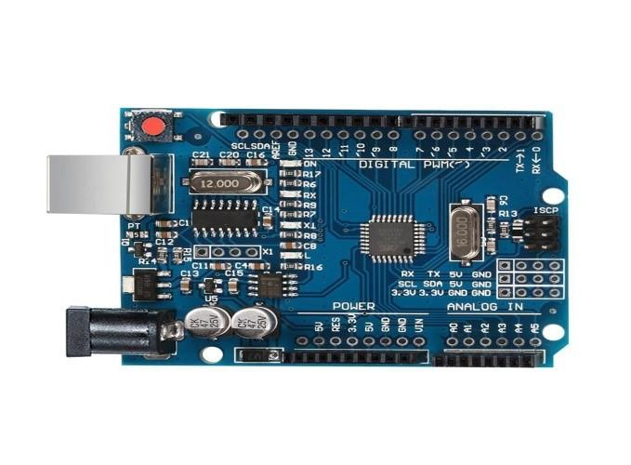
Fig.3.1 Arduino UNO Controller

3.4.2 U-blox 6 GPS module
The NEO-6 module series is a family of stand-alone GPS receivers featuring the high-performance u-blox 6 positioning engines. These flexible and cost-effective receivers offer numerous connectivity options in a miniature 16 x 12.2 x 2.4 mm package. Their compact architecture and power and memory options make NEO-6 modules ideal for battery operated mobile devices with very strict cost and space constraints.
The 50-channel u-blox 6 positioning engine boasts a Time-To-First Fix (TTFF) of under 1 second. The dedicated acquisition engine, with 2 million correlators, is capable of massive parallel time/frequency space searches, enabling it to find satellites instantly. Innovative design and technology suppress jamming sources and mitigates multipath effects, giving NEO-6 GPS receivers excellent navigation performance even in the most challenging environments.
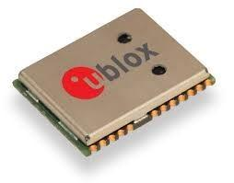Fig.3.2 GPS module
3.4.3 SIM800C GSM Module
SIM800C is a quad-band GSM/GPRS module that works on frequencies GSM850MHz, EGSM900MHz, DCS1800MHz and PCS1900MHz. SIM800C features GPRS multi slot class10/class12 (optional) and supports the GPRS coding schemes CS-1, CS-2, CS-3 and CS-4. With a tiny configuration of 17.6*15.7*2.3mm, SIM800C can meet almost all the space requirements in customers’ applications, such as smartphones, PDA and other mobile devices. SIM800C is a SMT package with 42 pads and provides all hardware interfaces between the module and customers’ boards. ⦁ One 3 lines serial port and one full modem serial port;
⦁ One USB, the USB interface can debug, download software; ⦁ One audio channel which include a microphone input and a speaker output;
⦁Programmable general purpose input and output;
⦁One SIM card interface;
⦁Support Bluetooth (need software support).

SIM800C is designed with power saving technique so that the current consumption is as low as 0.6mA in sleep mode.
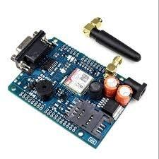Fig.3.3 SIM800C GSM Module
3.4.4 GY-291 ADXL345 3-Axis Accelerometer Module
GY-291 ADXL345 3-Axis Accelerometer is a sensor board based on ADXL345 accelerometer integrated circuit. The ADXL345 is a small, thin, ultralow power, 3-axis accelerometer with high resolution (13-bit) measurement at up to ±16 g. Digital output data is formatted as 16-bit twos complement and is accessible through either a SPI (3or 4-wire) or I2C digital interface.
The ADXL345 is well suited for mobile device applications. It measures the static acceleration of gravity in tilt-sensing applications, as well as dynamic acceleration resulting from motion or shock. Its high resolution (3.9 mg/LSB) enables measurement of inclination changes less than 1.0°.
Several special sensing functions are provided. Activity and inactivity sensing detect the presence or lack of motion by comparing the acceleration on any axis with user-set thresholds. Tap sensing detects single and double taps in any direction. Freefall sensing detects if the device is falling. These functions can be mapped individually to either of two interrupt output pins
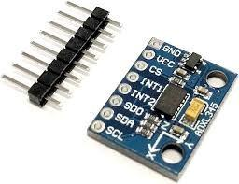
Fig.3.4 GY-291 ADXL345 3-Axis Accelerometer Module

3.4.5 Arduino Baseboard specifications

⦁ | 16*2 Lcd Display | =01
⦁ | Dc Female Socket | =01
⦁ | 1000/25v Capacitors | =01
⦁ | 100/25v Capacitors | =01
⦁ | 7805 Regulators | =01
⦁ | 5mm Red Led | =01
⦁ | 2 pin Male Connectors | =As Per Our Requirement
⦁ | Uno Baseboard | =01
⦁ | 1 K Resistor | =01
⦁ | Male Bucks | =01
⦁ | Female Bucks | =01
⦁ | Arduino Microcontroller | =01
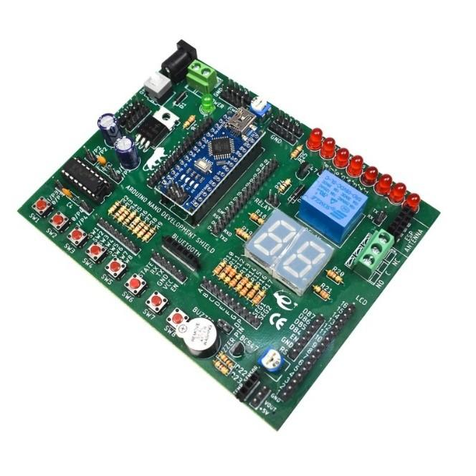
Fig.3.5 Arduino Baseboard
3.4.6 Regulated Power Supply
Rated Voltage : 100 – 240V AC
Variation Range : 90 – 264V AC
Rated Frequency : 50/60Hz
Variation Frequency : 47 – 63Hz
Input Current : 0.6A Max. @ Any input AC voltage & output full load
Inrush Current : 35A Max. Cold start @ 240V AC input, rated output load &
25°C ambient
AC Leakage Current : 0.25mA Max. @ 240V AC input
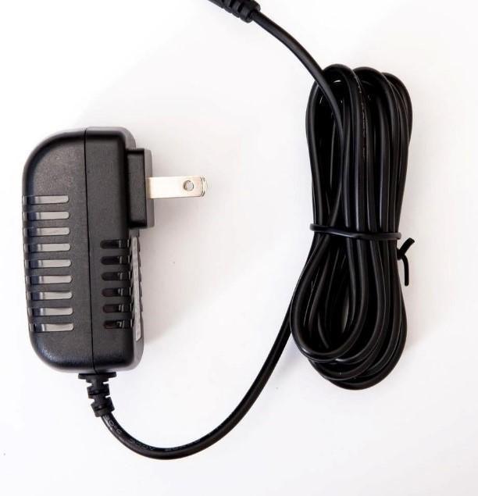
Fig.3.6 12v Adapter

3.4.7 16X2 LCD Display and A Switch
The 12x12x15mm Tactile Push Button Switch is widely used as a standard input button on electronic projects. These work best when you mount it on a PCB but can also be used on a solderless breadboard for temporary connections in prototypes. The pins are normally open (disconnected) and when the button is pressed they are momentarily closed and complete the circuit.
This tact switch also offers reliable dome contact technology and strong tactile feedback, with multiple operating forces to choose from. Applications include telecommunications, consumer electronics, audio/visual, medical devices, testing/instrumentation, and computer/peripherals.
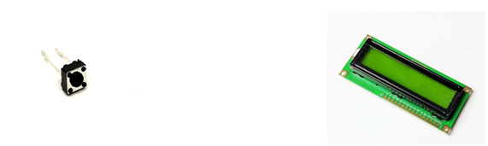Fig.3.7.1 Switch Fig.3.7.2. 16X2 LCD DISPLAY
Features of LCD Display

⦁5x8 dots with cursor
⦁16characters *2lines display
⦁4-bit or 8-bit MPU interfaces
⦁Built-in controller (ST7066 or equivalent)
⦁Display Mode & Backlight Variations
⦁ROHS Compliant
3.4.8 RFID Card
Radio Frequency Identification (RFID) is one of the most exciting technologies. The purpose of this paper is to review RFID technology and its applications. This paper gives a brief introduction to principles of RFID, classification of RFID tags and reader, frequencies used, current application, as well as advantages and limitations.

Fig.3.8. RFID Cards

3.4.9 LED- red diffused 5mm and buzzer
Features of LED:
⦁Tapered Barrel T−1 3/4 Package
⦁High Intensity Red light source with various lens colours and effects
⦁Versatile Mounting on PC Board or Panel
⦁T−1 3/4 with Stand−off Features of buzzer
⦁With internal drive circuit
⦁Sealed structure
⦁Wave solderable and washable
⦁Housing material: Noryl
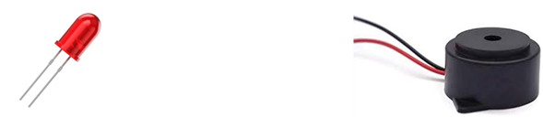Fig.3.9.1 LED Fig.3.9.2 Buzzer
3.5 SOFTWARE REQUIREMENT SPECIFICATION
Hardware Requirements:
System : Intel Core i7
Hard Disk : 1 TB
Ram : 16 GB
Sensors : DHT11, MEMS, RFID TAG
Relay : One Channel 5V DC

Software Requirements:
Operating System :Windows 11, Android 8,9.
Coding Language : C, Arduino Programming
Tools : GSM module, Arduino UNO, GPS

3.6 COST
S.no | Name of the component | No.of items | Cost in rupees
1 | Arduino uno | 1 | 500
2 | GSM Module | 1 | 1000
3 | GPS | 1 | 500
4 | Accelerometer | 1 | 250
5 | Arduino baseboard | 1 | 300
6 | Regulated power supply | 1 | 500
7 | 16*2 LCD Display | 1 | 300
8 | RFID card | 3 | 100
9 | LED | 2 | 50
10 | Buzzer | 1 | 100
11 | Battery | 3 | 1000
12 | RFID tag | 1 | 100
13 | Switch | 1 | 50
14 | Jumper wires | 40 | 100
15 | Miscellaneous | - | 1000
16 | Contingency | - | 500
 | Total |  | 6200

4. SYSTEM DESIGN
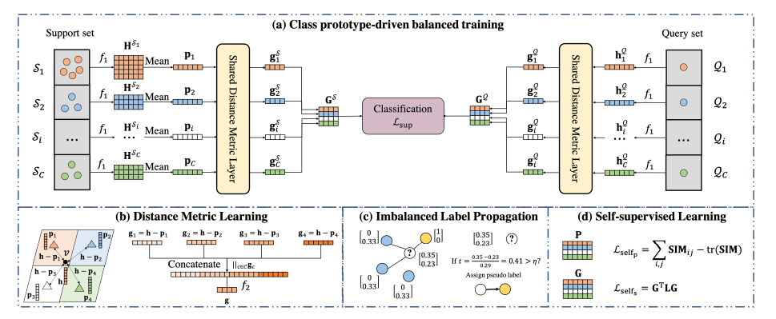
Fig. 1. Framework.
DPGNN is composed of four components: (a) Class prototype-driven balanced training inspired by episodic training from prototypical networks to balance the training loss across different classes via prototype-driven balanced training, (b) Distance metric learning it further introduce distance metric learning to better capture node distances to class prototypes, (c) Imbalanced label propagation a new imbalanced label propagation scheme to augment the training data and employ self-supervised learning to further improve the distance metric representations, (d) Self-supervised learning employ self-supervised learning to further improve the distance metric representations.
Class Prototype-Driven Balanced Training
In order to balance the training loss from majority and minority classes, we leverage the idea of episodic training by sampling support and query sets, and then calculating representations of prototypes for each class. In order to avoid using the original sparse and high-dimensional node features and to allow learned complex feature transformation, we first apply a GNN-based encoder f₁: ℝ^{nxd} x ℝ^{nxn} →ℝ^{nxd’} to obtain d’ -dimensional node representations H ⋴ ℝ^{nxd’} . Most GNN-based encoders f₁ can be decomposed into two components: neighborhood propagation and feature transformation, which can be generally formalized as:
h_{i}^{l} = TRAN^{l} (AGGR^{l} ( h_{i}^{l-1} , PROP^{l} ({ h_{j}^{l-1} | v_{j} ⋴ N_{i} }))),
where in each layer l, the representations { h_{j}^{l-1} | v_{j} ⋴ N_{i} } of the neighbors are first propagated via PROP^{l}; to node v_{i} and aggregated with its own representation h_{i}^{l-1} by AGGR^{l}; , then the combined representation is further transformed by TRAN^{l}; to output the representation h_{i}^{l} of node v_{i} after layer l of the GNN.
With the learned node embeddings H coming from the GNN-based encoder’s last layer, we aim to compute representations of class prototypes P⋴ ℝ^{Cxd’}. During each training epoch, the model is fed with an episode sampled from the abelled training nodes V_{l} is further divided into support sets S = {Sc |c ⋴ C} and query sets Q = {Q_{c} | c ⋴ C } of each class. The query sets only contain one training sample from each class and provide a balanced way to train the encoder. The support sets are formed by grouping the remaining training samples from each class except the query samples from the query sets, which serves as anchors to characterize the class prototypes of each class. Based on Prototypical Networks , we define class prototypes to be closely surrounded by nodes of the same class, such that they can precisely represent their class. More specifically, the prototype p_{c} of class c is computed by:
p_{c} = PROTO(H^{Sc}) = PROTO({h_{i} |v_{i} ⋴Sc }),c ⋴ C
where PROTO is the prototype computation which calculates the representation of a class prototype p_{c} based on node representations H^{Sc} that come from the support set Sc . For instance, in the vanilla Prototypical Network, the mean-pooling is employed here: .
p_{c =} $\frac{1}{| Sc |} \sum_{vi ⋴Sc }{}$h_{i ,c ⋴ C}
Applying mean-pooling to calculate class prototypes assumes that each class can be represented using only one class prototype, which might be under-representative when a unimodal distribution assumption is violated. Thus, multi-prototypes to represent each class could be used, such as replacing mean-pooling with another permutation-invariant function (e.g., K-means clustering), or even iteratively learn multi-prototypes according to the complexity of the class distribution. We leave this as one future direction. Prototypes serve as representatives of each class and can be used to classify query nodes by selecting their nearest prototypes. However, directly employing a softmax over distances to prototypes in the embedding space to obtain the class probability distribution will make different dimensions of distance contribute equally to the classification and in high dimensional data pairwise Euclidean distances tend to converge . Furthermore, using only embedding distance of a node to the nearest prototype omit its embedding distance to all other non-nearest prototypes that may encode extra information about the node’s class. Thus, instead of classifying query nodes directly based on their nearest prototype, we devise a distance metric layer to project nodes from the original embedding space to another distance metric space, where query nodes are classified by comparing their learned distance metric representations with the ones of class prototypes.
Distance Metric Learning
In order to project each node from the original embedding space to the distance metric space, we first concatenate the difference of its embedding from each class prototype. Next we apply a linear transformation on top of that, to pay different attention on each original distance dimension and adaptively extract useful distance information. Figure 1(b) demonstrates the detailed procedure of computing distance metric representation g of node v .
Given a node v with embedding h ⋴ ℝ^{d’}, we calculate its distance metric representation g_{c} ⋴ ℝ^{d’} to each class prototype 2 as:
g_{c} = h- p_{c} , c ⋴ C
where h- p_{c} calculates the difference of the embedding between each node and each class prototype. For each node, only considering its embedding difference to one class prototype cannot fully locate its position. Therefore, we concatenate the difference of the node’s embedding to all class prototypes ||_{c⋴{1,..,C}} g_{c} and further apply a linear transformation f₂ : ℝ^{d’C} → ℝ^{d”} to pay different levels of attention to different dimensions of the embedding difference and adaptively extract useful embedding difference information.
G = f₂ (||_{c⋴,C}g_{c} ).
The distance metric representation g encodes the distance information of the node v to all class prototypes, which as a result precisely captures its relative position to all class prototypes. In order to use these distance metric representations to prototypes for reference to classify query nodes, we feed the representations of prototypes and query nodes p_{c} , h_{c}^{Q} , for c ⋴ C into the shared distance metric layer to learn their distance metric representations g_{c}^{S} , g_{c}^{Q} , for c ⋴ C. Then we stack them across all classes to compute the distance metric representations of prototypes and query nodes:
G^{M} = stack(g_{c}^{M} | c ⋴ C),M ⋴ {Q,S}. Next, the predicted class distribution for each query node is:
F = softmax(G^{Q} (G^{S})^{T}) ,
where F2 gives the predicted probability distribution of class c’s query node over all classes, which is then used to calculate the supervised classification loss:
ℒ_{class} = $\frac{1}{C }$ $\sum_{c=1}^{C}{}$ ℓ(F_{c,} C),
where ℓ(·, ·) is a loss function to measure the difference between predictions and ground-truth labels, such as cross entropy.
Imbalanced Label Propagation
Network homophily assumes that connected nodes tend to share similar attributes or belong to the same class, which is commonly the case in various real-world networks. Thus, it be can naturally harnessed to augment the training data especially for increasing the minority training nodes. Motivated by this, we perform imbalanced label propagation to annotate node labels based on their neighboring nodes’ labels and filter out unconfident ones by computing their topology information gain [5]. Since we only have access to the class information of abelled nodes V; and to balance the voting effect between the majority and the minority classes, for unlabeled nodes we mask their one hot labels by filling zero vector 0 and for abelled nodes we multiply their one-hot labels by the weighting factor :
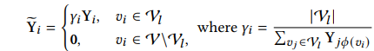

Moreover, nodes that fall in the topological boundary between different classes may possess noisy label distribution and mislead the training process. Therefore, we utilize the idea of topological information gain (TIG) [5] to filter out nodes with weak and obscure label distributions. TIG describes the task in formation effectiveness that the node obtains from abelled source along the network topology [5]. We regard the maximum entry of the soft-label b Y8 to be the most possible class type that the node E8 can be and the other entries as confusing information. Then the topological information gain t8 for node E8 is calculated as:
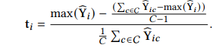
A high t_{i} means the label distribution of nodeE8 is sharp/strong and thus it lies in the cluster of nodes in class argmax. By network homophily, its label is also conjectured to be argmax. As such, we generate the hard pseudo label of non-training nodeE8 by binary thresholding its topological information gain t_{i} as
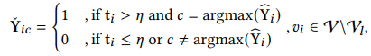
where is a hyperparameter that controls the trade-o between the quality and the number of the augmented labels. Higher[ leads to precise labels with sharp distribution and thus guarantee the abelled quality but less nodes could be augmented. Lower leads to more imprecise and noisy labels with even distribution. Note that for the initial abelled nodes we still utilize their original labels and thus the final labels we use for sampling support and query sets in class prototype-driven balanced training:
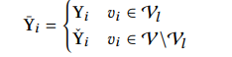
Self-Supervised Learning
Although node embeddings computed from the GNN-based encoder 51 embed network topology information, the prototype computation PROTO and the distance metric learning do not consider network topology. Inspired by the intuition that different class prototypes should have different representations and adjacent nodes should have similar distance metric representations, we design two GNN self-supervised learning (SSL) [20] pretext tasks to emphasize the topological information learned by DPGNN. To ensure that different prototypes have different representations, we minimize the representation similarity of prototypes from different classes as follows
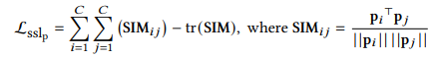

To smooth the distance metric representations between adjacent nodes and reinforce the graph structure in the learned representations, we adopt the following objective function:

Laplacian matrix can be written as :

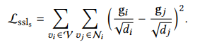

It is clear that ℒ_{ssls} is small when adjacent nodes share similar distance metric representations to class prototypes.

Collecting one supervised classification loss and two SSL loss, the overall objective function is stated as:

5. IMPLEMENTATION
MODULE 1
from dataset import *
from utils import *
from model import *
from learn import *

import argparse
import random
from torch import tensor
from tqdm import tqdm
import copy

parser = argparse.ArgumentParser()
parser.add_argument('--dataset', type=str, required=True)
parser.add_argument('--shuffle', type=str, required=True)
parser.add_argument('--encoder', type=str, required=True)
parser.add_argument('--episodic_samp', type=float, required=True)
parser.add_argument('--runs', type=int, required=True)
parser.add_argument('--imb_ratio', type=float, default=10)
parser.add_argument('--label_prop', type=str, required=True)
parser.add_argument('--eta', type=float, required=True)
parser.add_argument('--ssl', type=str, required=True)

parser.add_argument('--dropout', type=float, default=0.5)
parser.add_argument('--lamb1', type=float, default=1)
parser.add_argument('--lamb2', type=float, default=1)

parser.add_argument('--normalize_features', type=bool, default=True)
parser.add_argument('--early_stopping', type=int, default=0)
parser.add_argument('--epochs', type=int, default=3000)
parser.add_argument('--seed', type=int, default=100)
parser.add_argument('--n_hidden', type=int, default=256)
parser.add_argument('--weight_decay', type=float, default=5e-4)

args = parser.parse_args()

# load data
data, class_sample_num, args.num_classes, args.num_features, args.c_train_num, args.classes = load_data(
args.dataset, args.imb_ratio)
#print the number of training data for each class
print('The number of training data for each class', args.c_train_num)

if(args.ssl == 'yes'): #if using self-supervised learning component
deg_inv_sqrt = deg(data.edge_index, data.x)

F1 = np.zeros((args.runs, args.num_classes), dtype=float)
F1_weight = np.zeros(args.runs, dtype=float)
F1_micro = np.zeros(args.runs, dtype=float)
pbar = tqdm(range(args.runs), unit='run')

for count in pbar:
random.seed(args.seed + count)
np.random.seed(args.seed + count)
torch.manual_seed(args.seed + count)
torch.cuda.manual_seed(args.seed + count)

data = shuffle(data, args.num_classes, args.c_train_num)

if(args.label_prop == 'yes'):
y_prop = label_prop(data.edge_index, data.train_mask,
args.c_train_num, data.y, epochs=20)

# plot for tuning threshold \eta in imbalanced label propagation
# y_aug_trail(data.y, y_prop, args.c_train_num, data.val_mask)

y_aug, train_mask = sample(
data.train_mask, args.c_train_num, y_prop, data.y, eta=args.eta)

data.y_aug, data.train_mask = y_aug, train_mask

if(args.label_prop == 'no'):
data.y_aug, data.train_mask = data.y, data.train_mask

device = torch.device('cuda' if torch.cuda.is_available() else 'cpu')
data, proto = data.to(device), prototype().to(device)

if(args.ssl == 'yes'):
args.deg_inv_sqrt = deg_inv_sqrt.to(device)

if(args.encoder == 'GCN'):
encoder = GCN(args).to(device)

dist_encoder = dist_embed(args).to(device)
args.classes = args.classes.to(device)

model_param_group = []
if(args.encoder == 'GCN'):
model_param_group.append(
{'params': encoder.conv1.parameters(), 'lr': 1e-2, 'weight_decay': 5e-4})
model_param_group.append(
{'params': encoder.conv2.parameters(), 'lr': 1e-2, 'weight_decay': 0})

model_param_group.append(
{'params': dist_encoder.lin.parameters(), 'lr': 1e-2, 'weight_decay': 0})

optimizer = torch.optim.Adam(model_param_group)

criterion = torch.nn.NLLLoss()

best_val_f1_mean = 0
val_f1_history = []

for epoch in range(args.epochs):
train(encoder, dist_encoder, proto, data, optimizer, criterion, args)
f1, f1w, accs = test(encoder, dist_encoder, proto, data, args)

train_f1, val_f1, tmp_test_f1 = f1[0], f1[1], f1[2]
train_f1w, val_f1w, tmp_test_f1w = f1w[0], f1w[1], f1w[2]
train_acc, val_acc, tmp_test_acc = accs[0], accs[1], accs[2]

if np.mean(val_f1) > best_val_f1_mean:
best_val_f1_mean = np.mean(val_f1)
test_f1 = tmp_test_f1
test_acc = tmp_test_acc
test_f1w = tmp_test_f1w

# torch.save(encoder.state_dict(), 'encoder.pkl')
# torch.save(dist_encoder.state_dict(), 'dist_encoder.pkl')

val_f1_history.append(np.mean(val_f1))
if args.early_stopping > 0 and epoch > args.epochs // 2:
tmp = tensor(val_f1_history[-(args.early_stopping + 1): -1])
if np.mean(val_f1) < tmp.mean().item():
break

F1[count] = test_f1
F1_micro[count] = test_acc
F1_weight[count] = test_f1w

print('F1-macro:', np.sum(F1) / ((count + 1) * args.num_classes), 'F1-weight:', np.sum(F1_weight) / (count+1), 'F1-micro:', np.sum(F1_micro) / (count + 1))

print('Acc for each class:', np.mean(F1, axis = 0))
print('F1-macro: ', np.mean(F1))
print('F1-weight: ', np.mean(F1_weight))
print('F1-micro: ', np.mean(F1_micro))

MODULE 2

import torch
import torch.nn.functional as F
from torch_geometric.nn import GCNConv, MessagePassing
from torch.nn import Linear
from torch_geometric.utils import add_remaining_self_loops
from torch_scatter import scatter_add
import copy

class GCN(torch.nn.Module):
def __init__(self, args):
super(GCN, self).__init__()
self.conv1 = GCNConv(args.num_features, args.n_hidden)
self.conv2 = GCNConv(args.n_hidden, args.n_hidden)

def forward(self, data):
x, edge_index = data.x, data.edge_index
x = F.relu(self.conv1(x, edge_index))
x = F.dropout(x, training=self.training)
x = self.conv2(x, edge_index)
return x

class prototype(torch.nn.Module):
def __init__(self):
super(prototype, self).__init__()

def forward(self, x):
return torch.mean(x, dim = 0)

class dist_embed(torch.nn.Module):
def __init__(self, args):
super(dist_embed, self).__init__()
self.lin = Linear(args.n_hidden*args.num_classes, args.num_classes)

def forward(self, query, proto, classes):
d1 = query.size(0)
d2 = proto.size(0)

query = torch.repeat_interleave(query, d2, dim = 0)
proto = torch.tile(proto, (d1, 1))

dist = self.lin((query - proto).view(d1, -1))

return dist

def gcn_norm(edge_index, edge_weight=None, num_nodes=None, improved=False,
add_self_loops=True, dtype=None):

fill_value = 2. if improved else 1.
num_nodes = int(edge_index.max()) + 1 if num_nodes is None else num_nodes
if edge_weight is None:
edge_weight = torch.ones((edge_index.size(1), ), dtype=dtype,
device=edge_index.device)

if add_self_loops:
edge_index, tmp_edge_weight = add_remaining_self_loops(
edge_index, edge_weight, fill_value, num_nodes)
assert tmp_edge_weight is not None
edge_weight = tmp_edge_weight

row, col = edge_index[0], edge_index[1]
deg = scatter_add(edge_weight, col, dim=0, dim_size=num_nodes)
deg_inv_sqrt = deg.pow_(-0.5)
deg_inv_sqrt.masked_fill_(deg_inv_sqrt == float('inf'), 0)
return edge_index, deg_inv_sqrt[row] * edge_weight * deg_inv_sqrt[col]

class Prop(MessagePassing):
def __init__(self, num_classes, K=10, bias=True, **kwargs):
super(Prop, self).__init__(aggr='add', **kwargs)
self.K = K

def forward(self, x, edge_index, edge_weight=None):
edge_index, norm = gcn_norm(edge_index, edge_weight, x.size(0), dtype=x.dtype)

preds = []
preds.append(x)
for k in range(self.K):
x = self.propagate(edge_index, x=x, norm=norm)
preds.append(x)

pps = torch.stack(preds)
out = torch.sum(pps, dim = 0)
return out

def message(self, x_j, norm):
return norm.view(-1, 1) * x_j

def __repr__(self):
return '{}(K={})'.format(self.__class__.__name__, self.K)

MODULE 3

from torch_geometric.data import Data, InMemoryDataset, download_url
from torch_geometric.datasets import Planetoid, Amazon, CitationFull
import os.path as osp
import torch_geometric.transforms as T
import torch
from utils import *
import numpy as np
from typing import Optional, Callable
import copy

class Twitch(InMemoryDataset):
r"""The Twitch Gamer networks introduced in the
`"Multi-scale Attributed Node Embedding"
<https://arxiv.org/abs/1909.13021>`_ paper.
Nodes represent gamers on Twitch and edges are followerships between them.
Node features represent embeddings of games played by the Twitch users.
The task is to predict whether a user streams mature content.

Args:
root (string): Root directory where the dataset should be saved.
name (string): The name of the dataset (:obj:`"DE"`, :obj:`"EN"`,
:obj:`"ES"`, :obj:`"FR"`, :obj:`"PT"`, :obj:`"RU"`).
transform (callable, optional): A function/transform that takes in an
:obj:`torch_geometric.data.Data` object and returns a transformed
version. The data object will be transformed before every access.
(default: :obj:`None`)
pre_transform (callable, optional): A function/transform that takes in
an :obj:`torch_geometric.data.Data` object and returns a
transformed version. The data object will be transformed before
being saved to disk. (default: :obj:`None`)

"""

url = 'https://graphmining.ai/datasets/ptg/twitch'

def __init__(self, root: str, name: str,
transform: Optional[Callable] = None,
pre_transform: Optional[Callable] = None):
self.name = name
assert self.name in ['DE', 'EN', 'ES', 'FR', 'PT', 'RU']
super().__init__(root, transform, pre_transform)
self.data, self.slices = torch.load(self.processed_paths[0])

@property
def raw_dir(self) -> str:
return osp.join(self.root, self.name, 'raw')

@property
def processed_dir(self) -> str:
return osp.join(self.root, self.name, 'processed')

@property
def raw_file_names(self) -> str:
return f'{self.name}.npz'

@property
def processed_file_names(self) -> str:
return 'data.pt'

def download(self):
download_url(f'{self.url}/{self.name}.npz', self.raw_dir)

def process(self):
data = np.load(self.raw_paths[0], 'r', allow_pickle=True)
x = torch.from_numpy(data['features']).to(torch.float)
y = torch.from_numpy(data['target']).to(torch.long)

edge_index = torch.from_numpy(data['edges']).to(torch.long)
edge_index = edge_index.t().contiguous()

data = Data(x=x, y=y, edge_index=edge_index)

if self.pre_transform is not None:
data = self.pre_transform(data)

torch.save(self.collate([data]), self.processed_paths[0])

def index_to_mask(index, size):
mask = torch.zeros(size, dtype=torch.bool).to(index.device)
mask[index] = 1

return mask

def get_planetoid_dataset(name, normalize_features=False, transform=None):
path = osp.join(osp.dirname(osp.realpath(__file__)), '..', 'data', name)
dataset = Planetoid(path, name, transform=T.NormalizeFeatures())

if transform is not None and normalize_features:
dataset.transform = T.Compose([T.NormalizeFeatures(), transform])
elif normalize_features:
dataset.transform = T.NormalizeFeatures()
elif transform is not None:
dataset.transform = transform

return dataset

def get_twitch_dataset(name, normalize_features=False, transform=None):
path = osp.join(osp.dirname(osp.realpath(__file__)), '..', 'data', name)
dataset = Twitch(path, name, transform=T.NormalizeFeatures())

if transform is not None and normalize_features:
dataset.transform = T.Compose([T.NormalizeFeatures(), transform])
elif normalize_features:
dataset.transform = T.NormalizeFeatures()
elif transform is not None:
dataset.transform = transform

return dataset

def get_WebKB_dataset(name, normalize_features=False, transform=None):
path = osp.join(osp.dirname(osp.realpath(__file__)), '..', 'data', name)
dataset = WebKB(path, name, transform=T.NormalizeFeatures())

if transform is not None and normalize_features:
dataset.transform = T.Compose([T.NormalizeFeatures(), transform])
elif normalize_features:
dataset.transform = T.NormalizeFeatures()
elif transform is not None:
dataset.transform = transform

return dataset

def get_amazon_dataset(name, normalize_features=False, transform=None):
path = osp.join(osp.dirname(osp.realpath(__file__)), '..', 'data', name)
dataset = Amazon(path, name)

if transform is not None and normalize_features:
dataset.transform = T.Compose([T.NormalizeFeatures(), transform])
elif normalize_features:
dataset.transform = T.NormalizeFeatures()
elif transform is not None:
dataset.transform = transform

return dataset

def get_citationalfull_dataset(name, normalize_features=False, transform=None):
path = osp.join(osp.dirname(osp.realpath(__file__)), '..', 'data', name)
dataset = CitationFull(path, name)

if transform is not None and normalize_features:
dataset.transform = T.Compose([T.NormalizeFeatures(), transform])
elif normalize_features:
dataset.transform = T.NormalizeFeatures()
elif transform is not None:
dataset.transform = transform

return dataset

def load_data(dataname, imb_ratio):
if(dataname in ['Cora', 'Citeseer', 'Pubmed']):
dataset = get_planetoid_dataset(
dataname, transform=T.NormalizeFeatures())
class_sample_num = 2
classes = torch.unique(dataset.data.y)
if(dataname == 'Cora'):
ratio = [1] * 5 + [imb_ratio] * 2
if(dataname == 'Citeseer'):
ratio = [1] * 4 + [imb_ratio] * 2
if(dataname == 'Pubmed'):
ratio = [1] * 2 + [imb_ratio]

data = dataset[0]
num_classes = dataset.num_classes
num_features = dataset.num_features

if(dataname in ['Cora_ML', 'DBLP']):
dataset = get_citationalfull_dataset(
dataname, transform=T.NormalizeFeatures())
class_sample_num = 2
if(dataname == 'Cora_ML'):
ratio = [1] * 5 + [imb_ratio] * 2
if(dataname == 'DBLP'):
ratio = [1] * 3 + [imb_ratio]

data = dataset[0]
num_classes = dataset.num_classes
num_features = dataset.num_features

if(dataname in ['computers', 'photo']):
dataset = get_amazon_dataset(dataname, transform=T.NormalizeFeatures())
if(dataname == 'computers'):
class_sample_num = 50
if(dataname == 'photo'):
class_sample_num = 30
classes = torch.unique(dataset.data.y)
ratio = [((dataset.data.y == classes[i].item()).sum() /
dataset.data.y.size(0)).item() for i in range(len(classes))]

data = dataset[0]
num_classes = dataset.num_classes
num_features = dataset.num_features

if(dataname in ['DE', 'EN', 'ES', 'FR', 'PT', 'RU']):
dataset = get_twitch_dataset(
dataname, transform=T.NormalizeFeatures())
class_sample_num = 2
classes = torch.unique(dataset.data.y)
if(dataname == 'PT'):
ratio = [1] * 1 + [imb_ratio] * 1

data = dataset[0]
num_classes = dataset.num_classes
num_features = dataset.num_features

c_train_num = [int(ratio[i] * class_sample_num) for i in range(len(ratio))]

print('homophily', (dataset.data.y[dataset.data.edge_index[0]] == dataset.data.y[dataset.data.edge_index[1]]).sum()/len(dataset.data.edge_index[0]))

return data, class_sample_num, num_classes, num_features, torch.tensor(c_train_num), torch.arange(0, num_classes)

def shuffle(data, num_classes, num_training_nodes):
# Set new random planetoid splits:
# * 20 * num_classes labels for training
# * 500 labels for validation
# * 1000 labels for testing

indices = []
for i in range(num_classes):
index = torch.nonzero(data.y == i).view(-1)
index = index[torch.randperm(index.size(0))]
indices.append(index)

train_index, rest_index = [], []
for i in range(num_classes):
train_index.append(indices[i][:num_training_nodes[i]])
rest_index.append(indices[i][num_training_nodes[i]:])

train_index = torch.cat(train_index, dim=0)
rest_index = torch.cat(rest_index, dim=0)
rest_index = rest_index[torch.randperm(rest_index.size(0))]

data.train_mask = index_to_mask(train_index, size=data.num_nodes)
data.val_mask = index_to_mask(rest_index[:500], size=data.num_nodes)
data.test_mask = index_to_mask(rest_index[500:1500], size=data.num_nodes)

return data

MODULE 4

from utils import *
import torch
import copy

def train(encoder, dist_encoder, prototype, data, optimizer, criterion, args):
encoder.train()

support, query = episodic_generator(
data, args.episodic_samp, args.classes, data.x.size(0))

embedding = encoder(data)

support_embed = [embedding[support[i]] for i in range(len(args.classes))]

query_embed = [embedding[query[i]] for i in range(len(args.classes))]
query_size = [query_embed[i].size() for i in range(len(query_embed))]

query_embed = torch.stack(query_embed, dim=0)

proto_embed = [prototype(support_embed[i])
for i in range(len(args.classes))]

proto_embed = torch.stack(proto_embed, dim=0) # C*D

query_dist_embed = dist_encoder(query_embed, proto_embed, args.classes)
proto_dist_embed = dist_encoder(proto_embed, proto_embed, args.classes)

logits = torch.log_softmax(
torch.mm(query_dist_embed, proto_dist_embed), dim=1)

loss1 = criterion(logits, args.classes)

# topo
if(args.ssl == 'yes'):
dist_embed = dist_encoder(embedding, proto_embed, args.classes)
loss3 = torch.mean((dist_embed[data.edge_index[0]] * args.deg_inv_sqrt[data.edge_index[0]].view(-1, 1) -
dist_embed[data.edge_index[1]] * args.deg_inv_sqrt[data.edge_index[1]].view(-1, 1))**2)

class_sim = cos_sim_pair(proto_embed)
loss2 = (torch.sum(class_sim) - torch.trace(class_sim)) / \
((class_sim.size(0)**2 - class_sim.size(0)) / 2)
else:
loss3 = 0
loss2 = 0

loss = loss1 + args.lamb1 * loss2 + args.lamb2 * loss3

optimizer.zero_grad()
loss.backward()
optimizer.step()

def test(encoder, dist_encoder, prototype, data, args):
encoder.eval()

with torch.no_grad():
embedding = encoder(data)

support, query = episodic_generator(
data, 1, args.classes, data.x.size(0)) # take all samples in that class
support_embed = [embedding[support[i]]
for i in range(len(args.classes))]

proto_embed = [prototype(support_embed[i])
for i in range(len(args.classes))]

proto_embed = torch.stack(proto_embed, dim=0) # C*D

f1, f1w, acc = [], [], []
for _, mask in data('train_mask', 'val_mask', 'test_mask'):
y = data.y[mask]

query_embed = embedding[mask] # N*D
# query_dist = torch.cdist(query_embed, proto_embed, p = 2) #N*D, C*D --> N*C
query_dist_embed = dist_encoder(
query_embed, proto_embed, args.classes)
proto_dist_embed = dist_encoder(
proto_embed, proto_embed, args.classes)
# logits = torch.softmax(-query_dist, dim = 1) #N*C
logits = torch.log_softmax(
torch.mm(query_dist_embed, proto_dist_embed), dim=1)

pred = logits.max(dim=1)[1]

acc.append(pred.eq(y).sum().item() / mask.sum().item())
f1.append(f1_score(y.tolist(), pred.tolist(), labels=np.arange(
0, len(args.classes)), average=None, zero_division=0))
f1w.append(f1_score(y.tolist(), pred.tolist(), labels=np.arange(
0, len(args.classes)), average='weighted', zero_division=0))

return f1, f1w, acc

- OUTPUT SCREENSHOTS
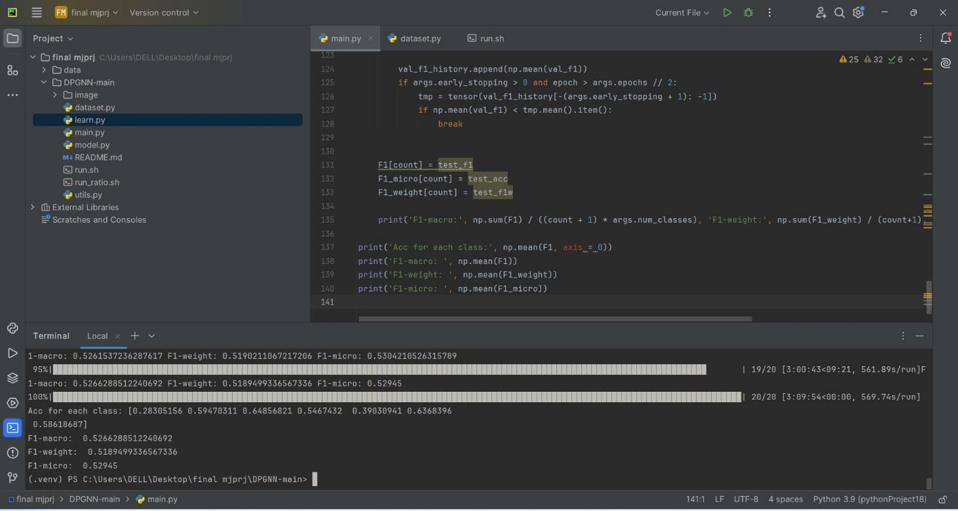

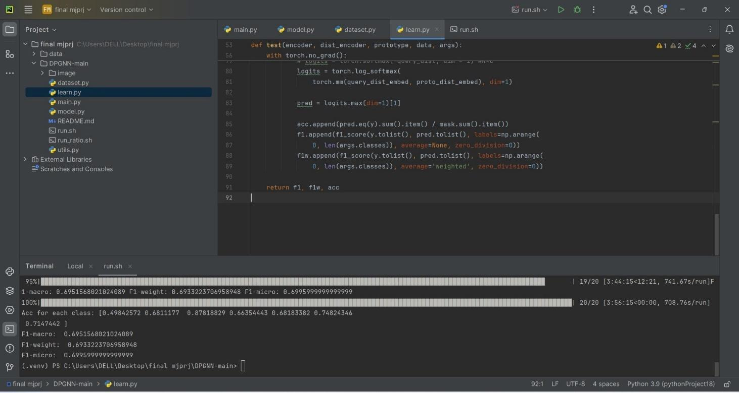

6.1 Output Result:

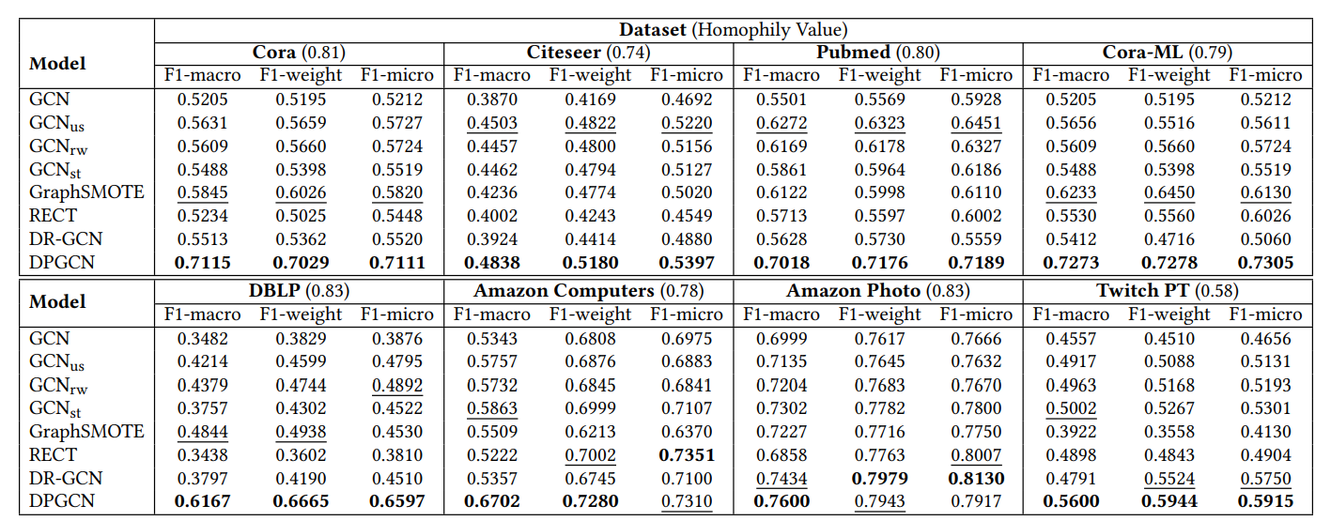
Table 1: Node classification performance on eight datasets with the best performance emboldened and second underlined

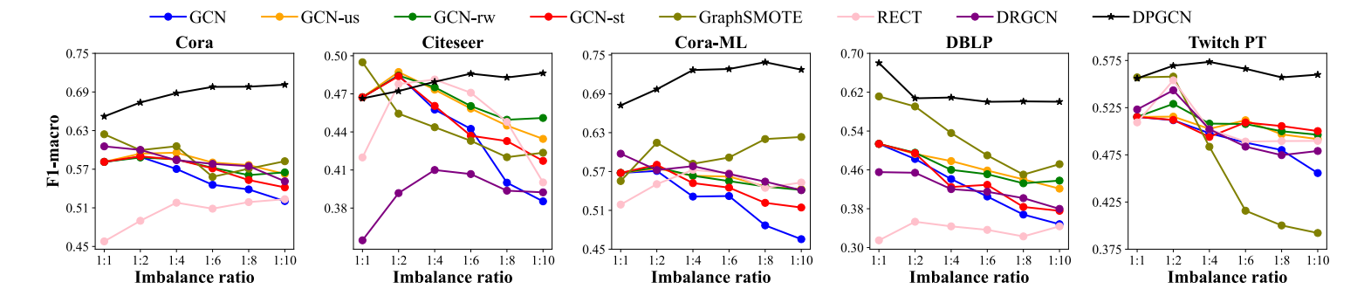

Figure 2: Node classification results under different class imbalance ratios.

7.CONCLUSION AND FUTURE WORK

The class imbalance problem in machine learning arises when the distribution of classes in a dataset is uneven, with one class significantly outnumbering the others. This imbalance can cause models to become biased towards the majority class, often resulting in poor predictive performance for the minority class, which might be critical in applications such as fraud detection, medical diagnosis, and anomaly detection. Standard metrics like accuracy can be misleading in such scenarios, as a model might achieve high accuracy by predominantly predicting the majority class. This issue necessitates the use of specialized techniques such as up-sampling, re-weight, GraphSmote ,DPGCN and appropriate evaluation metrics to ensure that models can effectively learn from and make accurate predictions for both majority and minority classes.

We focused on the imbalanced node classification problem in graphs, which widely exists in real-world setting such as malicious user detection and drug function testing. Noticing that imbalanced node classification naturally inherits issues of deep learning for imbalance classification: the inclination to learning towards majority classes and the catastrophic forgetting of previous learned instances in minority classes, we use a class prototype driven balance training scheme to balance the training loss between different classes. To further alleviate the issue of unrepresentative class prototypes, we construct another distance metric space to fully leverage the distance information of query nodes to all class prototypes. Moreover, we derive extra supervision from network topology by an imbalanced label propagation scheme and smooth the learned distance metric representation between adjacent nodes. Experiments on 8 real-world datasets demonstrate the effectiveness of the proposed DPGNN framework in relieving the class imbalance issue. For future work, we plan to study imbalanced graph classification and expect to utilize the graph topology as extra supervision.

REFRENCES
- Yu Wang, Charu Aggarwal, Tyler Derr 2022. Distance-wise Prototypical Graph Neural Network for Imbalanced Node Classification In MLG
- Yihong Ma, Yijun Tian, Nuno Moniz, and Nitesh V Chawla. 2023. Class-Imbalanced Learning on Graphs: A Survey. In University of NotreDame, USA
- Fenxiao chen, Yun-Cheng wang, Bin Wang and C.-C. Jay Kuo. Graph representation learning: a survey 2020
- Justin M. Johnson* and Taghi M. Khoshgoftaar 2019. Survey on deep learning with class imbalance
- Tianxiang Zhao, Xiang Zhang, and Suhang Wang. 2021. GraphSMOTE: Imbalanced Node Classification on Graphswith Graph Neural Networks. In WSDM
- Meng Liu, Hongyang Gao, and Shuiwang Ji. 2020. Towards Deeper Graph Neural Networks. In KDD
- Nitesh V Chawla, Kevin W Bowyer, Lawrence O Hall, and W Philip Kegelmeyer. 2002. SMOTE: Synthetic MinorityOver-sampling Technique. Journal of Artificial Intelligence Research (2002)

APPENDIX 1

RELEVANCE OF PROJECT TO POs / PSOs

Title of Project | Distance-wise Prototypical Graph Neural Network for Imbalanced Node Classification
Implementation  Details | Pycharm
Cost (hardware or software cost) | -
Type (Application, Product, model,  Review, etc.) | MODEL

 | Mapping with POs and PSOs with Justification
Relevance |  | PO  1 | PO  2 | PO  3 | PO  4 | PO  5 | PO  6 | PO  7 | PO  8 | PO  9 | PO 10 | PO 11 | PO 12 | PS  O 1 | PS  O 2
 |  | 3 | 3 | 3 | 3 | 3 | 3 | 2 | 3 | 3 | 3 | 3 | 3 | 3 | 3
Program  Outcomes  Justification |  | PO1: Engineering Knowledge: SDLC phases are followed in the execution of the project.  PO2: Problem Analysis: The different steps involved in Problem Analysis for formulation of the solution i.e. literature survey and use of fundamental subject knowledge has been followed.  PO3: Design/Development of solutions – Existing strategy has been enhanced using the design principles.  PO5: Modern Tool Usage: Pycharm, TensorFlow  PO6: The Engineer and Society: Students have developed the project which caters to the safety of the people in the society.  PO7: Environment and Sustainability: The developed project has positive impact on the society.
PO8: Ethics: Students have followed professional ethics during the various stages of Project completion.
PO9: Individual and Team Work: Students have worked both in individual as well as team capacity during the various stages of project work.
PO10: Communication: Effective communication with team members and during project reviews, project seminar and viva-voce has been exhibited.
PO11: Project management and Finance: The understanding of the engineering and management principles were demonstrated and applied to the project, as a member in a team, to manage projects in multidisciplinary environments.
PO12: Lifelong Learning. The project carried out gives the students scope to continue the work in the Computer Vision area in future.
Program  Specific  Outcomes  Justification |  | PSO1: Use of Pycharm  PSO2: Use of TensorFlow

APPENDIX 2
GANTT CHART

